Basic Schema of WeCureIT

ER Diagram:

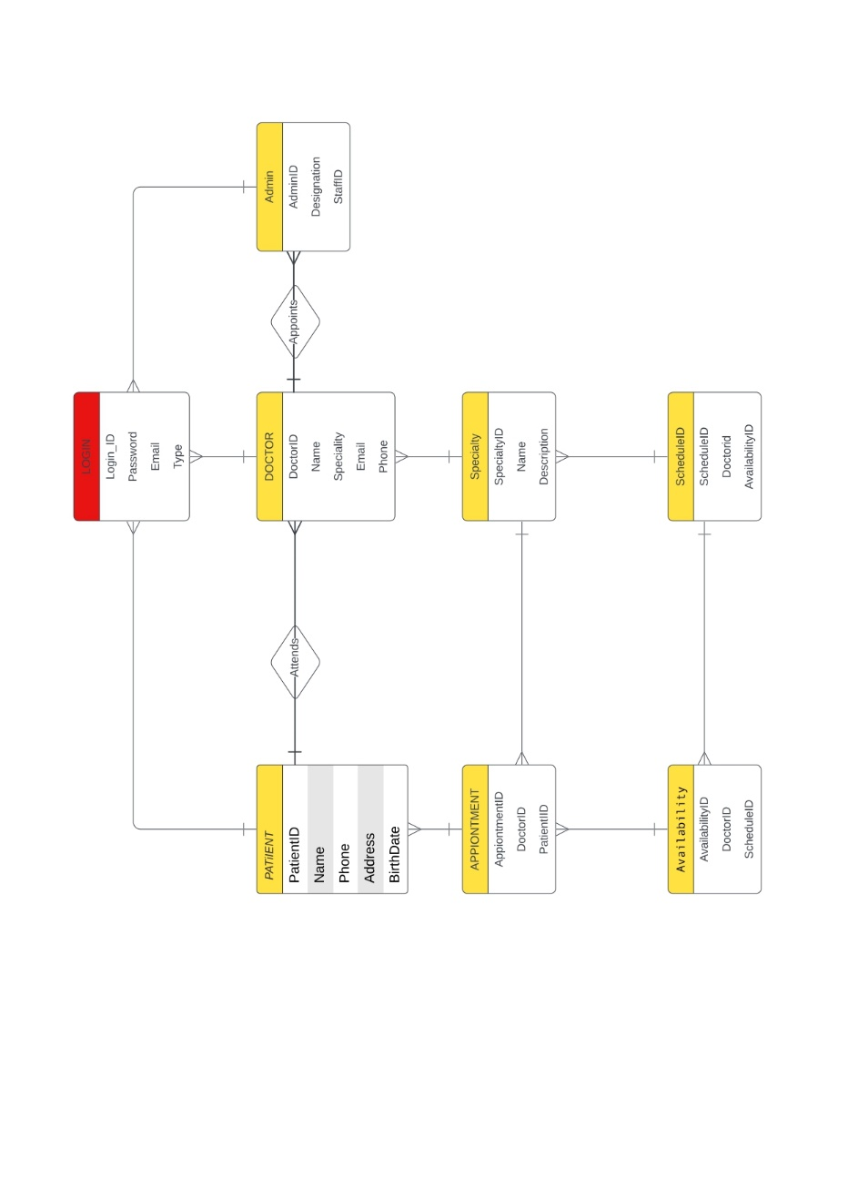

Patient Entity:

The “User” entity has one primary key:

->UserID: a primary key that uniquely identifies each user.

* The UserID attribute is used as the primary key to uniquely identify each user in the User entity. This allows us to perform operations such as inserting, updating, or deleting user records in the database.
* In addition to the primary key, the User entity may also contain other attributes such as Username, Password, Email, Name, Address, Phone, and DateOfBirth, depending on the specific requirements of the doctor appointment website. These attributes may be used to store additional information about each user, such as their contact details, personal information, or preferences.
* Overall, the User entity is an important entity in the doctor appointment website database, as it represents the users who can register, login, and book appointments on the website

Doctor Entity:

The Doctor entity has one primary key:

->DoctorID: a primary key that uniquely identifies each doctor.

* The DoctorID attribute is used as the primary key to uniquely identify each doctor in the Doctor entity. This allows us to perform operations such as inserting, updating, or deleting doctor records in the database.
* In addition to the primary key, the Doctor entity may also contain other attributes such as Name, Specialty, Email, Phone, Address, Description, Qualifications, and Experience, depending on the specific requirements of the doctor appointment website. These attributes may be used to store additional information about each doctor, such as their specialization, contact details, professional background, and expertise.
* Overall, the Doctor entity is an important entity in the doctor appointment website database, as it represents the doctors who have profiles on the website and with whom the users can book appointments.

Appointment Entity:

The Appointment entity has one primary key and two foreign keys:

->AppointmentID: a primary key that uniquely identifies each appointment.

->DoctorID: a foreign key that references the Doctor entity, indicating which doctor the appointment is with.

->UserID: a foreign key that references the User entity, indicating which user has booked the appointment.

* The primary key, AppointmentID, is used to uniquely identify each appointment in the Appointment entity. The foreign keys, DoctorID and UserID, establish relationships between the Appointment entity and the Doctor and User entities, respectively.
* By using foreign keys, we can link together related data across multiple tables in a database. For example, we can use the DoctorID foreign key to find all the appointments with a specific doctor, or use the UserID foreign key to find all the appointments booked by a specific user.
* In addition to the primary key and foreign keys, the Appointment entity may also contain other attributes such as AppointmentDate, StartTime, EndTime, and Status, depending on the specific requirements of the doctor appointment website. These attributes may be used to store information about the date, time, and status of each appointment.

Specialty Entity:

The Specialty entity has one primary key:

->SpecialtyID: a primary key that uniquely identifies each specialty.

* The SpecialtyID attribute is used as the primary key to uniquely identify each specialty in the Specialty entity. This allows us to perform operations such as inserting, updating, or deleting specialty records in the database.
* In addition to the primary key, the Specialty entity may also contain other attributes such as Name and Description, depending on the specific requirements of the doctor appointment website. These attributes may be used to store additional information about each specialty, such as its name and a brief description.
* Overall, the Specialty entity is an important entity in the doctor appointment website database, as it represents the different medical specialties that the doctors on the website can belong to.

Availability Entity:

The Availability entity has one primary key and two foreign keys:

->AvailabilityID: a primary key that uniquely identifies each availability slot.

->DoctorID: a foreign key that references the Doctor entity, indicating which doctor the availability slot belongs to.

->ScheduleID: a foreign key that references the Schedule entity, indicating which schedule the availability slot belongs to.

* The primary key, AvailabilityID, is used to uniquely identify each availability slot in the Availability entity. The foreign keys, DoctorID and ScheduleID, establish relationships between the Availability entity and the Doctor and Schedule entities, respectively.
* By using foreign keys, we can link together related data across multiple tables in a database. For example, we can use the DoctorID foreign key to find all the availability slots for a specific doctor, or use the ScheduleID foreign key to find all the availability slots for a specific schedule.

Schedule Entity:

The Schedule entity has one primary key and two foreign keys:

->ScheduleID: a primary key that uniquely identifies each schedule.

->DoctorID: a foreign key that references the Doctor entity, indicating which doctor the schedule is for.

->AvailabilityID: a foreign key that references the Availability entity, indicating which availability block is associated with the schedule.

* The primary key, ScheduleID, is used to uniquely identify each schedule in the Schedule entity. The foreign keys, DoctorID and AvailabilityID, establish relationships between the Schedule entity and the Doctor and Availability entities, respectively.
* By using foreign keys, we can link together related data across multiple tables in a database. For example, we can use the DoctorID foreign key to find all the schedules for a specific doctor, or use the AvailabilityID foreign key to find all the schedules associated with a specific availability block.
* In addition to the primary key and foreign keys, the Schedule entity may also contain other attributes such as Date and Status, depending on the specific requirements of the doctor appointment website. These attributes may be used to store information about the date and status of each schedule.